Mathematics
Grade 8
Rational Numbers

G8_ch1_im_1
- The shaded parts of the following patterns represent rational numbers P, Q, and R respectively.

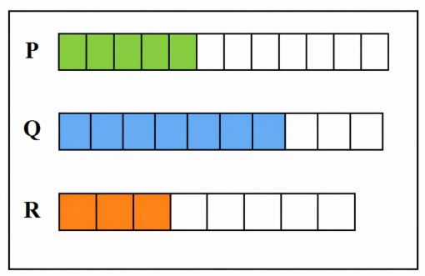

1. Which of the following expressions gives the greatest value?
A. P + R
B. Q − R
C. P + Q
D. Q − P
Answer: C

2. A student claims: “P + R = Q”. What is the correct conclusion?
A. Statement is true
B. Statement is false because P + R < Q
C. Statement is false because P + R > Q
D. Cannot be determined
Answer: C

3. Which operation results in a value greater than 1?
A. P + R
B. Q − R
C. P + Q
D. Q − P
Answer: C

4. If all three numbers are written with a common denominator of 40, what is the value of P?
A. 20/40
B. 24/40
C. 28/40
D. 30/40
Answer: B

5. Which of the following is closest to 1?
A. P
B. Q
C. R
D. P + R
Answer: B

- There are three containers P, Q, and R used to store rice. Their capacities are related as follows: Q is 3/4 of P R is 2/3 of Q.
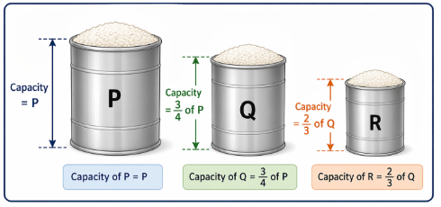

MCQs
- If the capacity of container P is 96 m³, what are the capacities of Q and R?
A. 72 m³ and 48 m³
B. 64 m³ and 48 m³
C. 72 m³ and 36 m³
D. 64 m³ and 36 m³
Answer: A

- What is the capacity of R in terms of P?
A. 1/2 of P
B. 1/3 of P
C. 1/4 of P
D. 3/4 of P
Answer: A

- If P = 120 m³, what is the difference between P and Q?
A. 20 m³
B. 25 m³
C. 30 m³
D. 40 m³
Answer: C

- Which of the following statements is correct?
A. Q = 2/3 P
B. R = 1/2 P
C. R = 3/4 P
D. Q = 1/2 P
Answer: B

- What is the ratio of capacities of Q and R?
A. 3 : 2
B. 2 : 3
C. 4 : 3
D. 3 : 4
Answer: A

